

**IADS Style Manual**

Controlled status: Public

Document Number: IADS- -STANDARD MANAGEMENT -2024

Issue Date: November 29, 2024 Implementation Date: December 1, 2024

|  |
| --- |
| Edited by: IADS Association Date: November 29, 2024 |
| Reviewed by: IADS Association Date: November 29, 2024 |
| Issued by: IADS Association Date: November 29, 2024 |

COPYRIGHT © INEV ALL DOMAINS SAFETY ASSOCIATION

**FOREWORD**

This document is established to ensure editorial consistency in IADS standard development and to provide authoritative guidelines for mandatory editorial review. All IADS standard development activities must adhere to the provisions outlined herein.

1. This manual supplements rather than replaces existing international standards. For matters not explicitly addressed, practitioners shall consult ISO/IEC Directives, Part 2 (Principles and rules for ISO/IEC document structure and drafting).

2. Developers encountering implementation questions or proposing substantive improvements during standard formulation should direct communications to the IADS Secretariat at [iadsafe@outlook.com](mailto:iadsafe@outlook.com).

3. IADS actively invites global automotive industry stakeholders to participate in standard development initiatives. Organizations seeking clarification or wishing to engage may contact the Secretariat through the official communication channel: iadsafe@outlook.com.

**COPYRIGHT PROTECTED DOCUMENT**

© IADS 2024

All rights reserved. Unless otherwise specified, or required in the context of its implementation, no part of this publication may be reproduced or utilized otherwise in any form or by any means, electronic or mechanical, including photocopying, or posting on the internet or an intranet, without prior written permission. Permission can be requested from IADS copyright office.

Tel: +852 8483 0334 E-mail: iadsafe@outlook.com Web: [www.iadsafe.org.](http://www.iadsafe.org.)

**IADS Style Manual**

1. **Font and spacing**

The standard text format should refer to **Table 1**

**Table 1 — standard text format**

|  |  |
| --- | --- |
| **Category** | **Requirements** |
| All font shall be **Arial** | |
| Font and spacing in **clause** | 1. Class 1 clause - **14** pounds, **6** pounds before and after the segment 2. Class 2 clause and below - **12** pounds, **6** pounds before and after the segment 3. line spacing **12** pounds |
| Font and spacing in **text** | 1. **10** pounds 2. **0** pounds before and **6** pounds after the segment 3. line spacing **12** pounds |
| Font in **table and figure** | 1. **9** pounds 2. line spacing **12** pounds |

1. **Definitions, acronyms, and abbreviations**

The format should refer to **Table 2**

**Table 2 — Definitions arrangement format**

|  |  |
| --- | --- |
| **Category** | **Requirements** |
| Original Definitions |  |
| Citation |  |
| Citation with adaption |  |

1. **Normative references and bibliography**

3.1 The reference should be arranged in **alphabetical order** in English according to the first letter

3.2 For reference with same first letter, it should be arranged in **numerical order**

3.3 If **specific clauses** from other standards are referenced in the main text, the specific year **should be indicated** in the normative reference

3.4 Files that are only informative elements should be included in the bibliography, the specific format should consult *The Chicago Manual of Style*

1. **Clause**

4.1 Hanging paragraphs should be avoided.

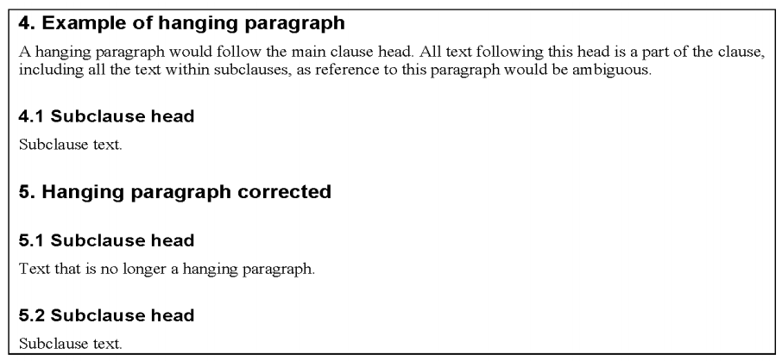

4.2 Lists should be arranged as follow:

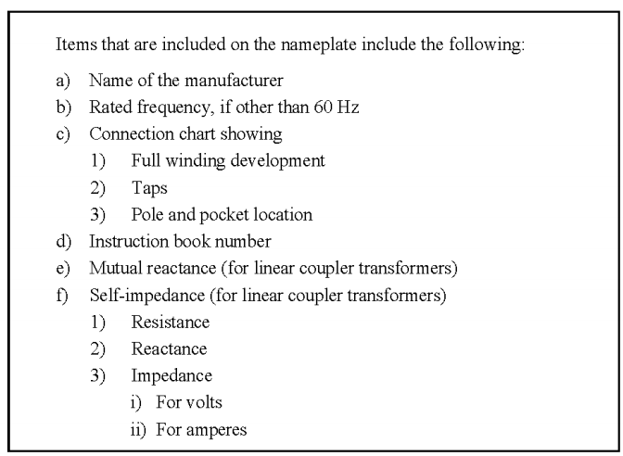

1. **Figure and Table**

**Table 3 — Figure arrangement requirements**

|  |  |
| --- | --- |
| **Category** | **Requirements** |
| DPI | **1200 DPI** at least, saved in **.tiff** |
| Size | Portrait page: maximum 21.59 cm×15.24 cm  Landscape page: maximum 15.24 cm×22.68 cm |
| Color | Preferred black and white lines |
| Color weight | at least 1.0 points |

**Figure 1 — Table arrangement requirements**

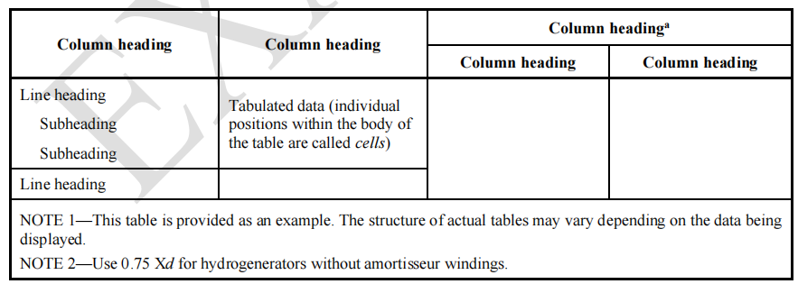

1. **Quantities, units, and letter symbols**

6.1 In general text, **isolated numbers less than 10 should be spelled out**. However, in equations, tables, figures, and other display elements, Arabic numerals should be used.

6.2 The value of a quantity shall be expressed by an **Arabic numeral followed by a space and the appropriate unit name or symbol**. An **upright (Roman) type font** should be used for the unit symbol.

6.3 If tolerances are provided, the unit shall be given with both the basic value and the **tolerance (e.g., 150 m ± 5 mm). Ranges should repeat the unit (e.g., 115 V to/~ 125 V). “-” can’t** be used to expressed range.

6.4 The physical quantity symbols shall be set in ***italic*** letters.

1. **About units**

Units should be expressed in the **SI unit system and the SI unit extension system.**