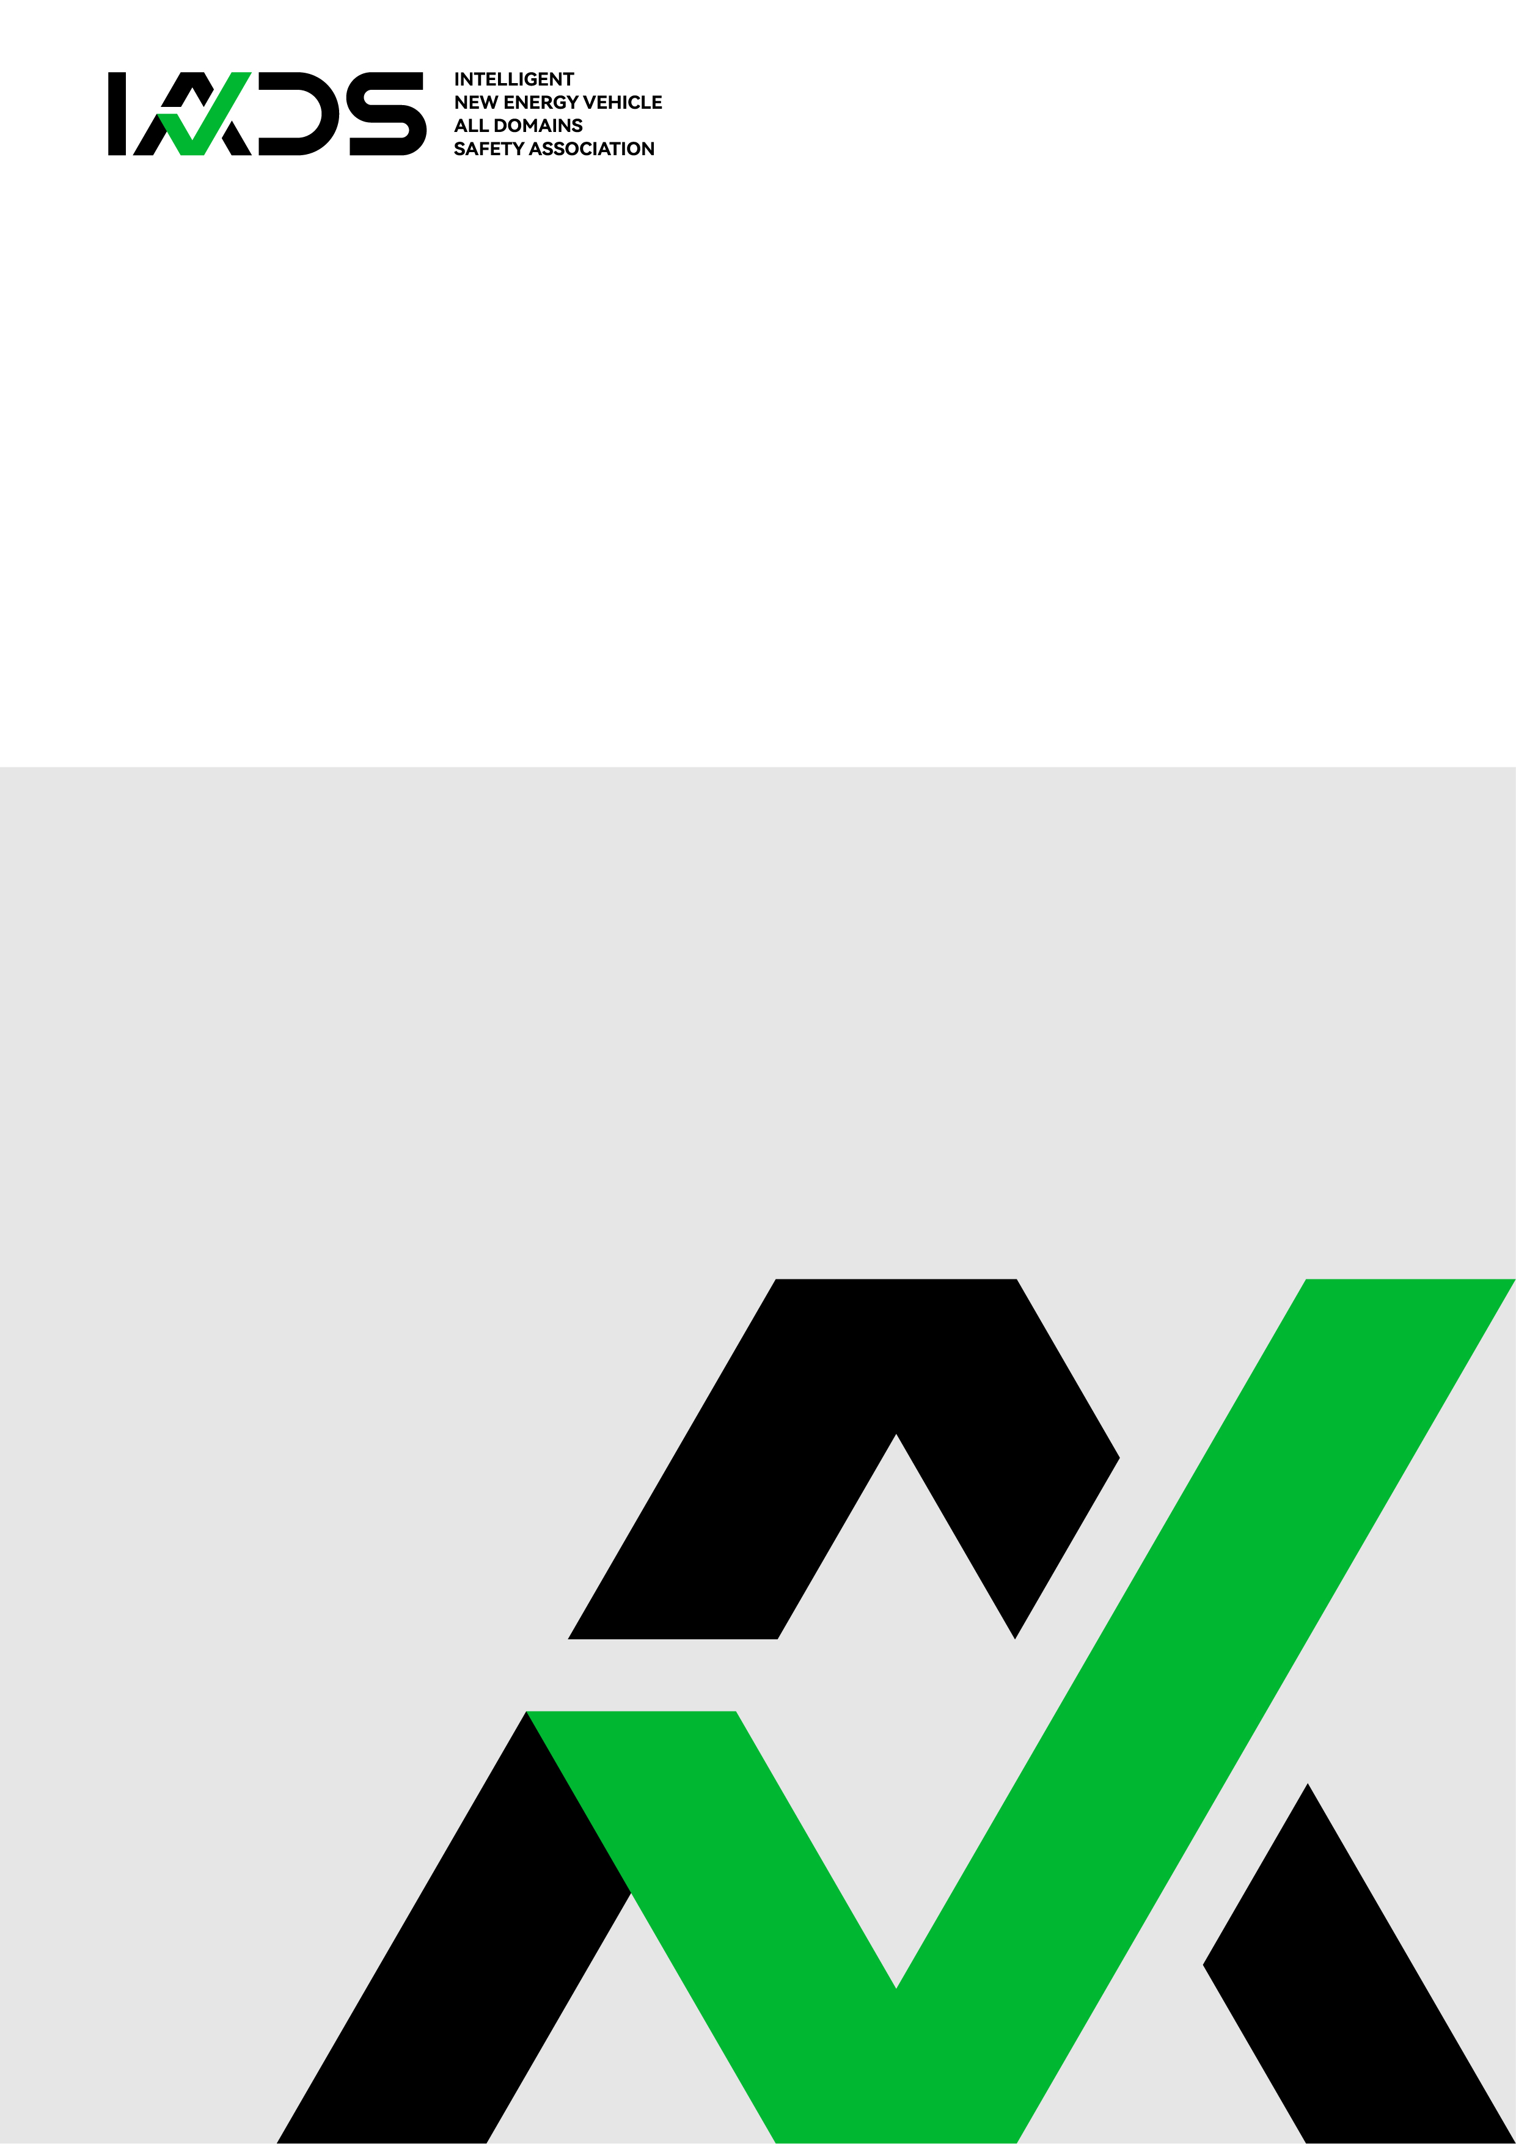

**IADS Association Standard**

**Standard Title**

Controlled status: Public

Document Number: IADS- 0001 -2025

Issue Date: November 29, 2024 Implementation Date: December 1, 2025





|  |
| --- |
| Edited by: IADS Association Date: November 29, 2024 |
| Reviewed by: IADS Association Date: November 29, 2024 |
| Issued by: IADS Association Date: November 29, 2024 |

**Driving Safety**

COPYRIGHT © INEV ALL DOMAINS SAFETY ASSOCIATION

**FOREWORD**

This document is established to ensure editorial consistency in IADS standard development and to provide authoritative guidelines for mandatory editorial review. All IADS standard development activities must adhere to the provisions outlined herein.

1. This manual supplements rather than replaces existing international standards. For matters not explicitly addressed, practitioners shall consult ISO/IEC Directives, Part 2 (Principles and rules for ISO/IEC document structure and drafting).

2. Developers encountering implementation questions or proposing substantive improvements during standard formulation should direct communications to the IADS Secretariat at [iadsafe@outlook.com](mailto:iadsafe@outlook.com).

3. IADS actively invites global automotive industry stakeholders to participate in standard development initiatives. Organizations seeking clarification or wishing to engage may contact the Secretariat through the official communication channel: [iadsafe@outlook.com](mailto:iadsafe@outlook.com).

**COMMENTS**

The IADS received 81 comments in response to the IADS-0001-2025 from a variety of commenters, including original equipment manufacturers, certificate authority, components and parts manufacturers, associations, and other leading international organizations and individuals. Automotive manufacturers commenting on the standard included: Geely, Li Auto, Tesla, Changan, BYD, and etc. Other automotive companies commenting on the standard included: Automotive certificate authority, governmental agencies, and industry associations commenting on the standard included: XXX, XXX, and etc.

While the IADS received only 81 comments, each comment detailed a wide array of discrete issues and recommendations. Some commenters provided general, high-level comments on the Standard. (general description of the comments and response)

**COPYRIGHT**

© IADS 2024

All rights reserved. Unless otherwise specified, or required in the context of its implementation, no part of this publication may be reproduced or utilized otherwise in any form or by any means, electronic or mechanical, including photocopying, or posting on the internet or an intranet, without prior written permission. Permission can be requested from IADS copyright office.

Tel: +852 8483 0334 E-mail: iadsafe@outlook.com Web: [www.iadsafe.org.](http://www.iadsafe.org.)

**PATENT**

The IADS Standard is established in accordance with the IADS Patent Policy.

Please note that the implementation of this standard may require the use of subject matter covered by patent rights. By issuing this standard, IADS takes no position regarding the existence or validity of any patent rights related to it. If a patent holder or patent applicant has submitted a Letter of Assurance by accepting the assurance letter, such a declaration will be listed on the IADS website at [www.iadsafe.org.](http://www.iadsafe.org.) The Letter of Assurance may indicate whether the submitter is willing or unwilling to grant patent licenses without compensation or under reasonable rates, terms, and conditions that are demonstrably free of any unfair discrimination against applicants seeking such licenses.

If no Letter of Assurance has been received, essential patent claims may exist. IADS is not responsible for identifying essential patent claims that may require licensing, investigating the legal validity or scope of patent claims, or determining whether any licensing terms or conditions related to submitted Letters of Assurance (if any) or any licensing agreements are reasonable or non-discriminatory. Users of this standard are expressly advised that determining the validity of any patent rights and the risk of infringing such rights rests entirely with them. Further information may be obtained from the IADS Standards Association.

**PARTICIPANTS**

<Convener> --------------------------------------------------------------------------------- name

<Secretary> -------------------------------------------------------------------------------- name

Company name ------------------------------------------------------------------------------ name

Company name ------------------------------------------------------------------------------ name

Company name ------------------------------------------------------------------------------ name

Company name ------------------------------------------------------------------------------ name

Company name ------------------------------------------------------------------------------ name

**ACKNOWLEDGEMENT**

Company name ------------------------------------------------------------------------------ name

Company name ------------------------------------------------------------------------------ name

**BALLOTERS**

**Contents**

Overview…………………………………………………………………………1

Scope…………………………………………………………………………… 1

**[Draft V1.0] Title**

1. **Overview**
2. **Scope**
3. **Normative references**
4. **Definitions, acronyms and abbreviations**
   1. **Definition**
   2. **Acronyms and abbreviations**
5. **Technical**

This should be the technical contents. Please consult *IADS style manual* for writing format. If you have any questions, please consult the IADS Secretariat [(iadsafe@outlook.com)](mailto:(iadsafe@outlook.com))

1. **Bibliography**

(Informative)

1. **XXXXXX**

(normative)